BDO India LLP
“AS IS” Analysis of UPSRLM Power BI Dashboard: 1.Critical Inefficiencies & Risk Analysis 2.Existing Manual Data Practices 3.Bottleneck Analysis 4.Technology Stack 5.Communication Channels 6.Data Flow Architecture 7.Key Performance Indicators (KPIs) Recording Period: 12th September 2025 to 17th September 2025
U.P. State Rural Livelihood Mission (PRERNA) Lucknow, Uttar Pradesh

Document Details
Project Name | As-Is Process Study-UPSRLM Power BI Analytical Dashboard
Date: | 12-09-2025 | Release | Ver 1.0
Author | Akash Tiwari, Shilpi Raizada
Owner | BDO India LLP
Client | U.P. State Rural Livelihood Mission (PRERNA)
Document Number | BDO-UPSRLM-AIPS-v1-PBID’2025

Approvals
Name | Title | Date of Issue | Version
Sachin Mishra | Project Manger | 17-09-2025 | 1.0
Team BDO |  |  | 1.0

Distribution
Name | Title | Date of Issue | Version
Ms. Deepa Ranjan | Mission Director (MD) – UPSRLM | 17-09-2025 | 1.0
Ms. Janmejay Shukla | Joint Mission Director (JMD) - UPSRLM | 17-09-2025 | 1.0

Table of Contents
1. Executive Summary 4
2. INTRODUCTION & SCOPE 5
3. Current Process Description (The "Manual Workflow") 6
3.1 Stages of the Manual Workflow 6
3.1.1. Stage 1: Field-Level Capture 6
3.1.2. Stage 2: Block-Level Aggregation 6
3.1.3. Stage 3: District-Level Consolidation 6
3.1.4. Stage 4: Manual Analysis 6
4. Departments Involved in Report Generation 7
5. Current Reporting Flow (AS-IS) 8
6. KEY PERFORMANCE INDICATORS (KPIs) 9
CBO Formation 9
Profiling Module 9
Start-up Fund 9
Member Details 9
SHG–VO Mapping 9
Revolving Fund 9
Community Investment Fund (CIF) 10
Bank Account 10
Transactions Module 10
Potential Lakhpati Didi 10
CLF Set-up 10
CLF Visioning, AAP & BDP 10
CLF – CMTC 10
7. Identified Pain Points & Bottlenecks 12
8. SWOT Analysis 13
Strengths 13
Weaknesses 13
Opportunities 13
Threats 13
9. Conclusion 14
Disclaimer 15

- Executive Summary
The UPSRLM Progress Tracking Dashboard represents an institutional attempt to transition from fragmented, manual information practices toward a centralized, analytics-driven performance monitoring framework. Conceptually, the dashboard functions as a decision-support system (DSS) built on Power BI, designed to aggregate, standardize, and visualize programme data generated across multiple administrative and thematic units.
From a theoretical standpoint, the dashboard addresses classic challenges in large-scale public programmes—namely information asymmetry, delayed feedback loops, and weak data governance. By consolidating district- and block-level indicators into a single analytical interface, the Power BI system seeks to establish a “single version of truth” for leadership review and comparative assessment.
However, while visualization and reporting are centralized, data generation and validation remain decentralized and largely manual. As a result, the system currently operates as a retrospective analytical layer, rather than a fully integrated real-time management information system.

Category | Current Operational Observation | Root Cause | Impact / Risk (Pre–Power BI) | Power BI Enablement / Resolution
Communication Channels | Informal calls, WhatsApp messages, ad-hoc Excel files | Absence of centralized reporting mechanism | Knowledge silos and loss of institutional memory | Single Power BI dashboard ensures uniform visibility
Data Capture (Field Level) | Manual data capture by CRPs | Paper-based, non-standard formats | Error propagation across reporting layers | Structured datasets feeding Power BI
Monitoring & Supervision | Manual follow-ups by BMMs/DMMs | No real-time dashboards | Delayed issue identification | Automated KPIs and drill-down views
Data Quality | 60–80% inaccuracies | Repeated transcription | Faulty decision-making | Standardized datasets and validations
Reporting Velocity | Delayed reports | Sequential manual approvals | Administrative lag | Near real-time analytical views

- INTRODUCTION & SCOPE
In theory, an effective performance monitoring system integrates three layers:
- Data Generation Layer – where raw operational data is captured
- Data Processing Layer – where data is validated, transformed, and aggregated
- Decision & Analytics Layer – where insights inform governance and action
The UPSRLM Power BI dashboard primarily strengthens the third layer—analytics and decision support—by providing standardized KPIs, scorecards, trend analysis, and comparative rankings. It consolidates data from heterogeneous sources such as LokOS, CLF Web Application, NRLM MIS, Bank Linkage systems, VPRP, and Annual Action Plans into a unified reporting framework.
The theoretical scope of the dashboard includes:
- Performance monitoring across administrative hierarchies
- Cross-thematic comparability of programme indicators
- Temporal trend analysis for review and accountability
- Structured evidence support for leadership decision-making
At present, limitations in the upstream layers constrain the dashboard’s ability to function as a real-time operational control system.

- Current Process Description (The "Manual Workflow")
From an organizational theory perspective, the existing reporting process reflects a highly decentralized and person-dependent information ecosystem. Data flows sequentially through individuals rather than systems, increasing the risk of distortion, delay, and loss.
Theoretical Data Flow Model (AS-IS)
- Field Actors (CRPs / Sakhis)
- Physical or Portal-Based Records
- Manual Compilation at Block Level
- Departmental Validation
- Excel-Based Aggregation
- Power BI Visualization
Each transition introduces transaction costs, interpretive bias, and error propagation, which collectively reduce data reliability.

3.1 Stages of the Manual Workflow
    - Stage 1: Field-Level Capture
The absence of standardized digital tools leads to non-uniform data recording practices. Theoretical implications include:
- High variance in data quality
- Dependence on individual cognition and interpretation
- Weak input validation
    - Stage 2: Block-Level Aggregation
Manual re-entry and consolidation increase entropy within the data system. From a systems theory lens, this stage represents data amplification of error, where inaccuracies multiply rather than stabilize.
    - Stage 3: District-Level Consolidation
Verification through verbal confirmation introduces subjectivity and reduces auditability. Information credibility depends on trust rather than system-enforced controls.
    - Stage 4: Manual Analysis
Without automated analytics, insights rely on post-hoc calculations. Decision-making becomes reactive rather than predictive.
Impact: Delayed corrective action and retrospective insights

- Departments Involved in Report Generation
In theoretical terms, each thematic department within UPSRLM functions as an independent data producer operating under loosely coupled governance mechanisms.

Department | Role in Information System
Social Mobilization | Institutional data generator
CLF Strengthening | Organizational performance source
Financial Inclusion | Transactional and financial data provider
Farm Livelihoods | Sectoral outcome reporting
Non-Farm Livelihoods | Enterprise and value-chain data
Planning & M&E | Strategic alignment and planning inputs
MIS & Analytics | Integrator and interpreter

Power BI acts as the convergence layer, where disparate data streams are reconciled into a coherent performance narrative.

- Current Reporting Flow (AS-IS)
Conceptually, the reporting architecture follows a batch-processing model, characterized by periodic updates and delayed insight generation.
Thematic Systems
1. Manual Extraction
2. Excel-Based Transformation
3. Power BI Refresh
4. Analytical Outputs
5. Review & Governance
Such a model prioritizes periodic accountability over continuous operational intelligence.

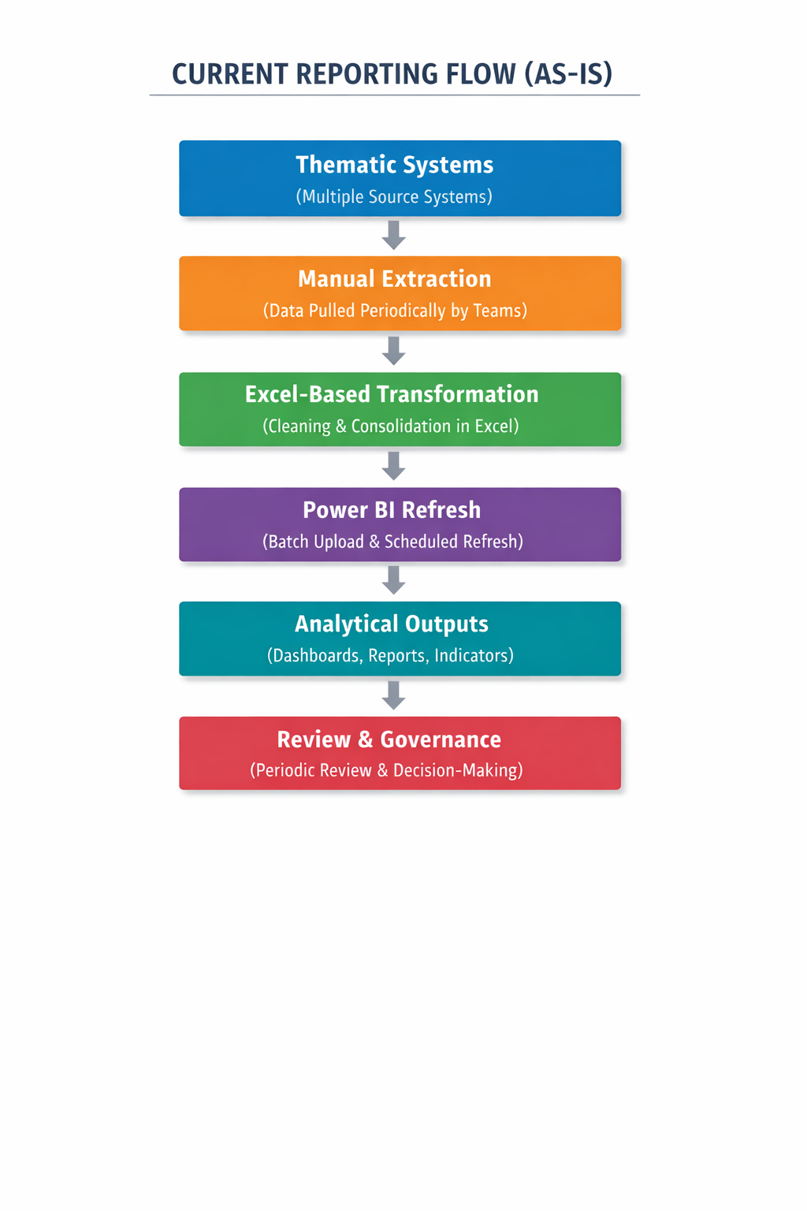

- KEY PERFORMANCE INDICATORS (KPIs)
Key performance indicators currently measure:

CBO Formation
- Number of CBOs Formed
- CBO Registration Rate
- Active CBO Percentage
- CBO Compliance Status

Profiling Module
- Member Profiling Coverage
- Household Profiling Completion Rate
- Profile Update Timeliness
- Vulnerable Household Identification Rate

Start-up Fund
- Start-up Fund Sanctioned
- Start-up Fund Disbursed
- Start-up Fund Utilization Rate
- Start-up Fund Beneficiary Coverage

Member Details
- Total Members
- Aadhaar/ID Coverage
- Bank Account Coverage
- Livelihood Participation Rate

SHG–VO Mapping
- SHGs Mapped to VOs
- Orphan SHGs
- Average SHGs per VO
- Mapping Accuracy Rate

Revolving Fund
- Revolving Fund Sanctioned
- Revolving Fund Disbursed
- Revolving Fund Utilization Rate
- Revolving Fund Repayment Rate

Community Investment Fund (CIF)
- CIF Sanctioned
- CIF Released
- CIF Utilization Rate
- CIF Repayment Rate

Bank Account
- SHG Bank Account Coverage
- VO Bank Account Coverage
- CLF Bank Account Coverage
- Active Account Percentage

Transactions Module
- Total Number of Transactions
- Transaction Value
- Digital Transaction Rate
- Transaction Reconciliation Rate

Potential Lakhpati Didi
- Potential LDs Identified
- Potential LDs Approved
- Lakhpati Didi Conversion Rate
- Average Income Enhancement

CLF Set-up
- CLFs Formed
- CLF Operational Status
- VO Coverage per CLF
- Governance Structure Completion

CLF Visioning, AAP & BDP
- Approved AAP Coverage
- Approved BDP Coverage
- Plan Implementation Progress
- Budget Utilization Rate

CLF – CMTC
- CMTCs Operational
- Trainings Conducted
- Participants Trained
- Training Completion Rate
From a theoretical standpoint, these KPIs reveal a system optimized for reporting compliance, rather than real-time performance management.

- Identified Pain Points & Bottlenecks
The identified bottlenecks represent structural inefficiencies, not individual failures. These include:
- Manual backend dependency
- Fragmented data ownership
- Absence of automated validation
- Limited audit trails
- High coordination overhead
Together, these constraints limit scalability and increase organizational risk.

- SWOT Analysis

Strengths
- Centralized analytical visibility
- Standardized performance language
- Strong human capital at field level

Weaknesses
- Manual data pipelines
- Inconsistent data governance

Opportunities
- Automation of data ingestion
- Advanced analytics and forecasting

Threats
- Over-reliance on small technical teams
- Strategic risk from inaccurate or delayed data

- Conclusion
From a theoretical perspective, the UPSRLM Power BI dashboard represents a partial yet significant phase of digital transformation within a large-scale public-sector programme. The system has effectively institutionalized a centralized analytics and reporting framework that standardizes performance measurement across districts, blocks, and thematic verticals. By consolidating diverse programme indicators into a single analytical interface, the dashboard enhances transparency, enables cross-geographical comparability, and strengthens governance by supporting structured, evidence-based decision-making at senior administrative levels.
At the same time, the persistence of manual, decentralized, and sequential data generation processes imposes structural constraints on the system’s ability to function as a real-time management tool. Data capture, validation, and consolidation remain heavily dependent on human intervention, paper-based practices, and fragmented MIS platforms. These upstream limitations disrupt feedback loops, delay insight availability, and introduce variability in data quality. Consequently, the Power BI dashboard primarily operates as a retrospective performance review mechanism, offering historical insights rather than continuous operational intelligence or predictive oversight.
The current AS-IS state reveals a clear evolutionary pathway in the digital maturity lifecycle of the programme. UPSRLM has successfully transitioned from informal, ad-hoc reporting toward visualization-driven performance monitoring; however, it has not yet achieved full system integration or automation. To advance toward a mature performance management ecosystem, emphasis must shift from visualization alone to end-to-end data governance, encompassing standardized data models, automated ingestion pipelines, embedded validation controls, and auditable data lineage.
Strengthening upstream data pipelines and governance frameworks is therefore not merely a technical enhancement but an institutional requirement. Robust automation and validation mechanisms would reduce dependency on manual interventions, improve data reliability, and enable near real-time insight generation. Such a transition would allow Power BI to evolve from a reporting and review tool into an integrated management control system, capable of supporting proactive supervision, early warning signals, and adaptive programme management across large-scale livelihood interventions.
.

Disclaimer
- By accessing, viewing, or using this Power BI dashboard and its associated documentation, the reader acknowledges and agrees to the terms and conditions stated herein.
- The scope of work for the Power BI dashboard is strictly limited to the objectives, deliverables, and responsibilities defined under the approved assignment scope agreed with UPSRLM. Any use beyond the agreed scope shall be at the sole discretion and risk of the user.
- This Power BI dashboard and accompanying report (hereinafter referred to as the “Report”) have been prepared exclusively for internal use by UPSRLM and its authorized stakeholders. The Report shall not be relied upon by any third party. No part of this Report may be reproduced, distributed, or disclosed to any third party without prior written approval from the authorized dashboard-owning authority.
- The analyses, KPIs, visualizations, trends, and rankings presented in the Report are based solely on data, documentation, and information provided by various thematic departments and source systems, including but not limited to LokOS, CLF Web Application, NRLM MIS, VPRP, Bank Linkage systems, Google Sheets, and Annual Action Plans. No independent verification of source data has been undertaken unless explicitly stated.
- The procedures performed and findings reflected in this Report are limited to data consolidation, transformation, visualization, and analytical presentation. In the event that additional or revised information becomes available after publication or refresh, there is no obligation to update or amend the Report unless separately agreed.
- Certain observations and interpretations contained in this Report are based on discussions with departmental representatives and review meetings and may not always be supported by formal written documentation. No representation is made regarding the sufficiency or completeness of procedures performed for any purpose other than the intended internal use.
- This engagement does not constitute an audit, attestation, certification, or assurance engagement under applicable auditing or accounting standards. Accordingly, no assurance, opinion, or certification regarding accuracy, completeness, or compliance is expressed or implied.
- The dashboard development and reporting team shall not be held liable for any loss, damage, or consequence arising from inaccurate, incomplete, delayed, or misrepresented data provided by source departments, or from reliance placed on the dashboard outputs without independent verification.
- The dashboard outputs, scorecards, and rankings are analytical in nature and are intended to support informed decision-making. They should not be construed as definitive, legally binding, or regulatory records.
- All work has been executed in accordance with the defined scope of work, agreed methodologies, and reporting frameworks approved by UPSRLM.

WHAT MATTERS TO YOU,
MATTERS TO US.

FOR MORE INFORMATION:
Anurag Srivastava- Partner
+91 – 9717004947| AnuragSrivastava@bdo.in

BDO INDIA LLP, an Indian limited liability partnership, is a member of BDO International Limited, a UK company limited by guarantee, and forms part of the international BDO network of independent member firms.

BDO is the brand name for the BDO network and for each of the BDO Member Firms.
Copyright © Aug 2021, BDO INDIA LLP. All rights reserved.
www.bdo.in

